# Says

What have we heard them say? What can we imagine them saying?

# Thinks

What are their wants, needs, hopes, and dreams? What other thoughts might influence their behavior?

## To get a easy visa slot

They need simple to book

They need more communication from our side

Advance level of travelling experience

They have more availability and

more slots

Customers need easy to use this application

They need more slots and availability

## ABISHON J

CRM Application That helps to Book a Visa Slot

It is safe and secure

They need to check the slots anytime and anywhere

It needs extra money

They can return the slots

It's time duration is large

personal and emotions factors are expected

# Does Feels

What behavior have we observed? What can we imagine them doing?

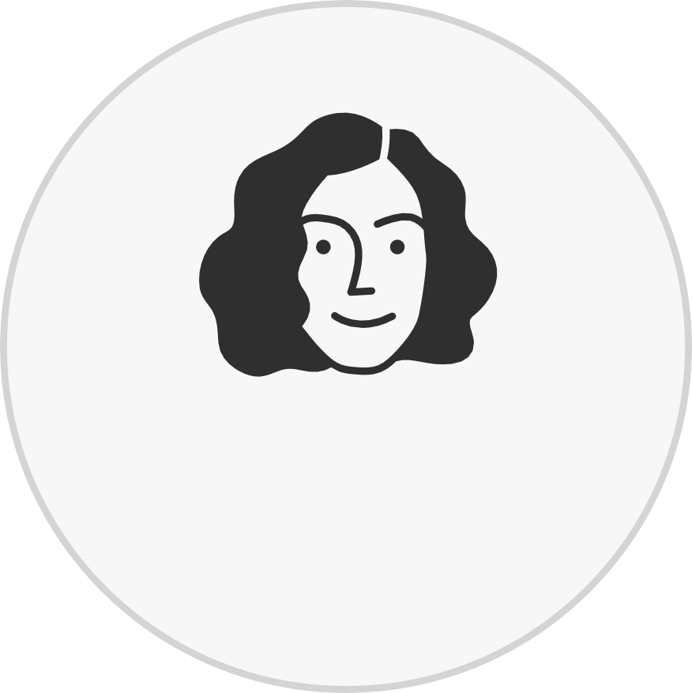

[**See an example**](https://app.mural.co/template/8734e26b-e4c9-45b9-a5ba-03ce4aa3c700/ca1d645e-05be-4feb-94bb-f670d5f20e7c)

What are their fears, frustrations, and anxieties? What other feelings might influence their behavior?